ENGSCI 9510 Assignment #4 – Xinyu Yun

Question 1:

A. Please see the Expected monetary value(EMV ) bellowed:

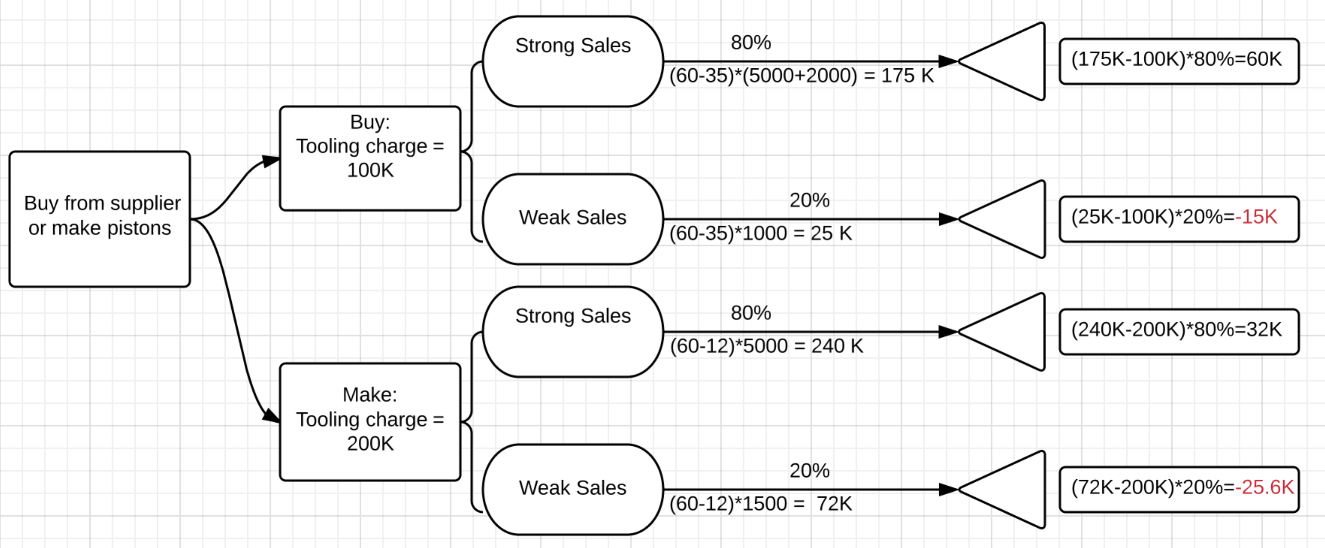

The final evaluated income will be:

Buy: 60k-15k = 45K

Make: 32K – 25.6K = 6.4K

So buying from supplier would be the better option.

B. Risk:

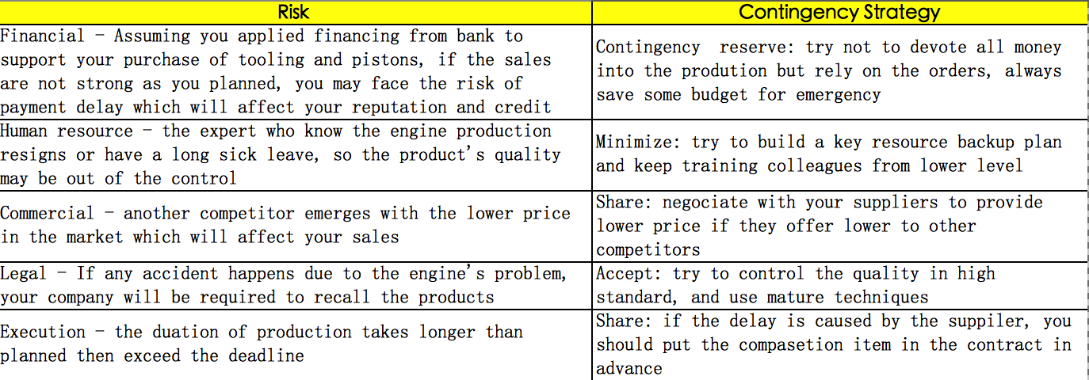

Question 2:

Here are the EMV analyses:

Opportunity 1

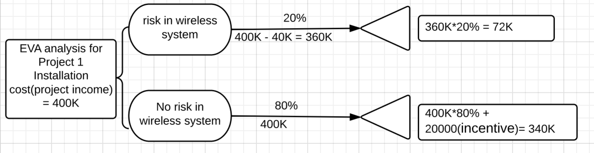

The evaluated income will be 72K+340K = 412K

Opportunity 2

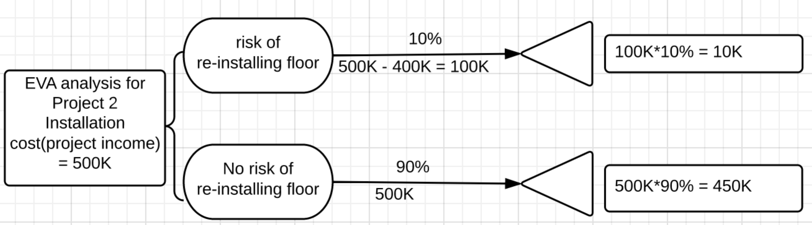

The evaluated income will be 10k+450K = 460K.

Opportunity 3

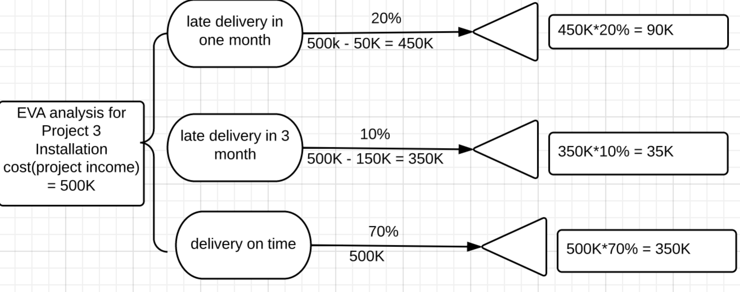

The evaluated income will be 90k+35K+350K = 475k

So opportunity 3 would be the best choice.